BILATERAL FILTERING

1. CODE

function [new_image,rmsd]=myBilateralFiltering(sigma_s,sigma_r)

a=load('../data/barbara.mat');

orig_image=a.imageOrig;

orig_image=orig_image/255.0;

%imwrite(orig_image,'../images/original_image.png');

[row,col]=size(orig_image);

image = imnoise(orig_image,'gaussian',0.0004);

%imwrite(image,'../images/blurred_image.png');

%Parameters

window=9;

[row,col]=size(image);

[x_val y_val]=meshgrid(-window:window,-window:window);

space_filter=exp(-(x_val.^2+y_val.^2)/(2*sigma_s^2));

final_image=image;

for i=1:row

for j=1:col

row_min=max(i-window,1);

col_min=max(j-window,1);

row_max=min(i+window,row);

col_max=min(j+window,col);

cropped_image=image(row_min:row_max,col_min:col_max);

range_filter=exp(-double(cropped_image-image(i,j)).^2/(2*sigma_r^2));

filter_matrix=range_filter.*space_filter((row_min:row_max)+window+1-i, ...

(col_min:col_max)+window+1-j);

W=sum(filter_matrix(:));

final_image(i,j)=sum(sum(filter_matrix.*double(cropped_image)))/W;

end

end

rmsd=sqrt(norm(final_image-orig_image)^2/(row*col));

%imwrite(final_image,'../images/final_image.png');

1. Final result:

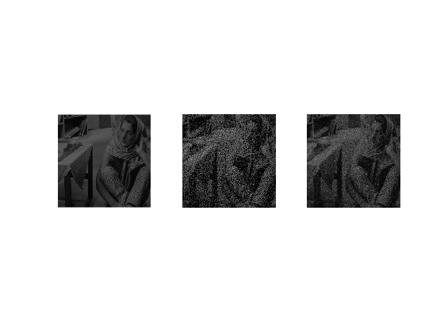

1. Gaussian space filter mask:



1. Optimal values:

Sigma for range filter= 0.11

Sigma for space filter= 2

Optimal RMSD value= 0.0066

1. A. RMSD value for sigma_space=1.8 and sigma_r=0.11 : 0.0068

B. RMSD value for sigma_space=2.2 and sigma_r=0.11 : 0.0068

C. RMSD value for sigma_space=2 and sigma_r=0.10 : 0.0069

D. RMSD value for sigma_space=2 and sigma_r=0.12 : 0.0069